VLC Media Player

Introduction

**VLC media player** (commonly known as just **VLC**) is a [free and open-source](https://en.wikipedia.org/wiki/Free_and_open-source_software) [portable](https://en.wikipedia.org/wiki/Software_portability) [cross-platform](https://en.wikipedia.org/wiki/Cross-platform) [media player software](https://en.wikipedia.org/wiki/Media_player_software) and [streaming media](https://en.wikipedia.org/wiki/Streaming_media) [server](https://en.wikipedia.org/wiki/Server_(computing)) developed by the [VideoLAN](https://en.wikipedia.org/wiki/VideoLAN) project. VLC is available for desktop [operating systems](https://en.wikipedia.org/wiki/Operating_system) and [mobile platforms](https://en.wikipedia.org/wiki/Mobile_platform), such as [Android](https://en.wikipedia.org/wiki/Android_(operating_system)), [iOS](https://en.wikipedia.org/wiki/IOS), [iPadOS](https://en.wikipedia.org/wiki/IPadOS), [Tizen](https://en.wikipedia.org/wiki/Tizen), [Windows 10 Mobile](https://en.wikipedia.org/wiki/Windows_10_Mobile) and [Windows Phone](https://en.wikipedia.org/wiki/Windows_Phone). VLC is also available on [digital distribution platforms](https://en.wikipedia.org/wiki/Digital_distribution_platform) such as Apple's [App Store](https://en.wikipedia.org/wiki/App_Store_(iOS)), [Google Play](https://en.wikipedia.org/wiki/Google_Play) and [Microsoft Store](https://en.wikipedia.org/wiki/Microsoft_Store_(digital)).

VLC supports many [audio and video compression](https://en.wikipedia.org/wiki/Data_compression) methods and [file formats](https://en.wikipedia.org/wiki/File_format), including [DVD-Video](https://en.wikipedia.org/wiki/DVD-Video), [video CD](https://en.wikipedia.org/wiki/Video_CD) and streaming [protocols](https://en.wikipedia.org/wiki/Communications_protocol). It is able to stream media over [computer networks](https://en.wikipedia.org/wiki/Computer_network) and to [transcode](https://en.wikipedia.org/wiki/Transcode) multimedia files.

The VideoLAN project began as a student endeavor at [École Centrale Paris](https://en.wikipedia.org/wiki/%C3%89cole_Centrale_Paris) (France), but after releasing the software under the [free software](https://en.wikipedia.org/wiki/Free_software_license)/[open source](https://en.wikipedia.org/wiki/Open_source_license) [GNU General Public License](https://en.wikipedia.org/wiki/GNU_General_Public_License), the project is now multinational with a development team spanning 40 nationsThe project has been completely separated from École Centrale Paris since 2009 when it was constituted as a non-profit organization.

The default distribution of VLC includes many free decoding and encoding libraries, avoiding the need for finding/calibrating proprietary plugins. The [libavcodec](https://en.wikipedia.org/wiki/Libavcodec) library from the [FFmpeg](https://en.wikipedia.org/wiki/FFmpeg) project provides many of VLC's codecs, but the player mainly uses its own [muxers](https://en.wikipedia.org/wiki/Muxer) and demuxers. **VLC** is **made** by the non-profit foundation VideoLAN. It started as a student project at the French École Centrale, Paris but is now a worldwide project with developers from 20 countries. (more about its history).

# [How to Download and Install VLC Media Player](https://www.wikihow.com/Download-and-Install-VLC-Media-Player)

This shows you how to install the free VLC media player on your computer or smartphone. VLC is available for Windows, Mac, iPhone, and Android platforms.

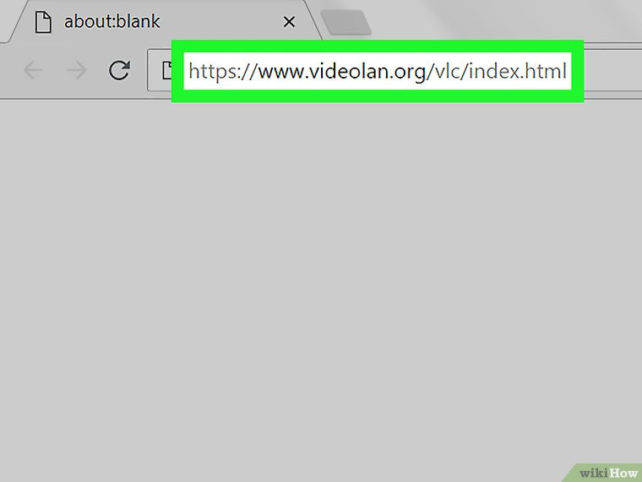

**1.Open the**[**VLC website**](https://www.videolan.org/vlc/index.html)**.** Type <https://www.videolan.org/vlc/index.html> in your computer's web browser.

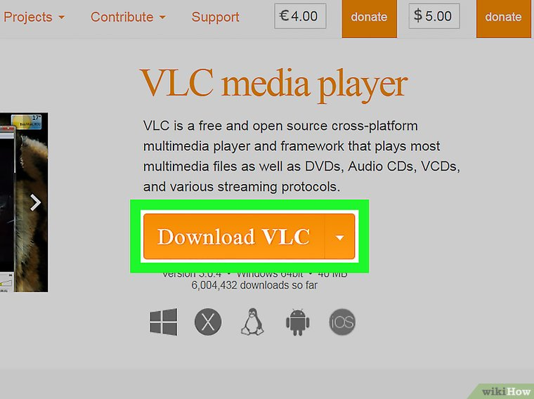

**2.Click Download VLC.** It's an orange button on the right side of the page.

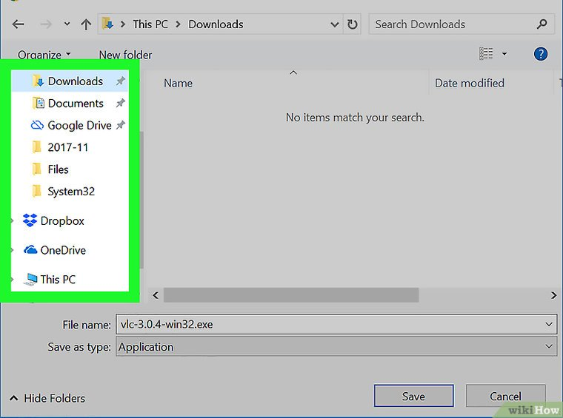

**3.Select a download location if prompted.** Doing so will allow the VLC setup file to download onto your computer.

The VLC file will download automatically, so if you aren't prompted for a download location, skip this step.

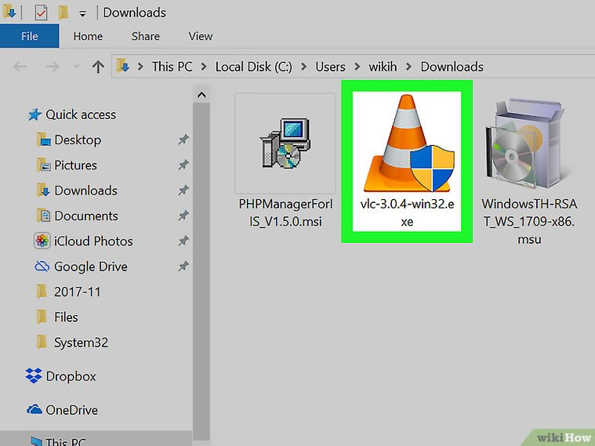

**4.Double-click the downloaded VLC setup file.** You'll find it in the default downloads location for your browser.

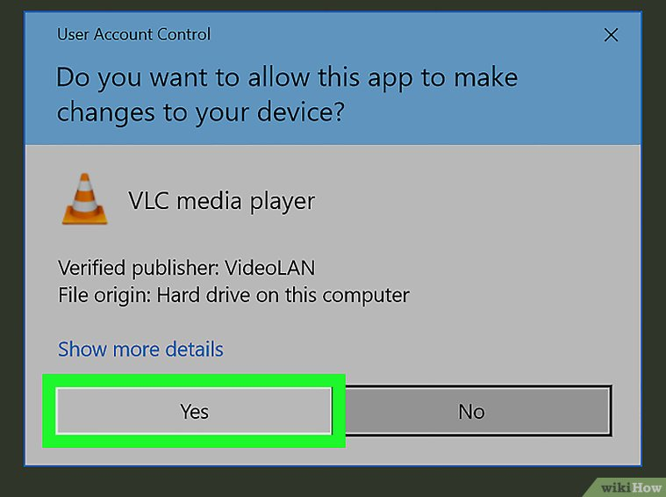

**5.Click Yes when prompted.** Doing so opens the installation window.

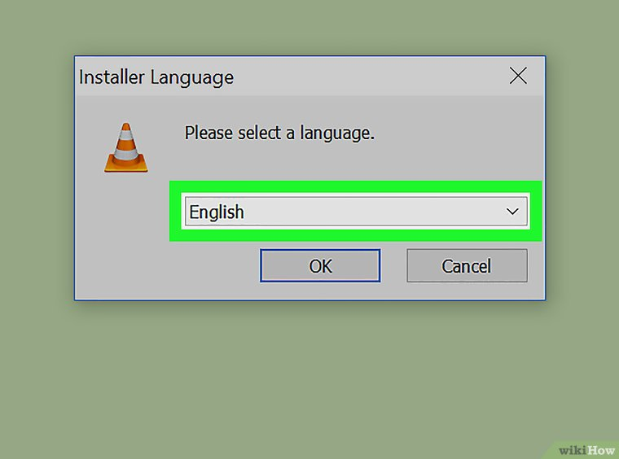

**6.Select a language.** When asked, click the language drop-down box and select the language you want to use for VLC Media Player, then click **OK** to proceed.

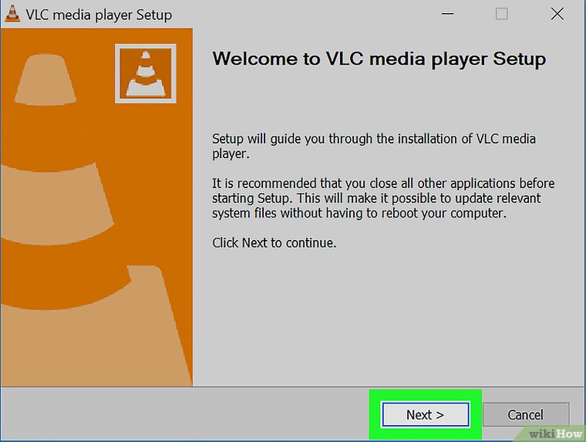

**7.Click Install.** It's at the bottom of the page. Doing so installs VLC Media Player on your computer.

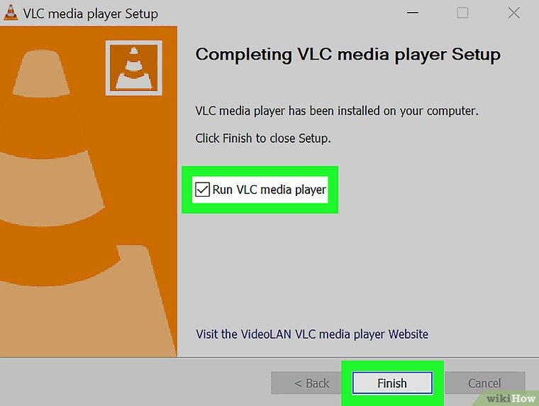

**9.Run VLC Media Player.** Immediately after installing VLC, you can run it by making sure the "Run VLC media player" box is checked and clicking **Finish**.

When you want to run VLC in the future, you'll double-click the VLC app icon on your desktop or select it from Start.